
My Target:
____ /52 or _____% Complete on the day of the test.   (Circle when your test is handed back)

Task One – Introduction to History (Year 7)
In-class Short Answer Response (4%)

____ / 52
Name: __________________________

READING TIME – 5 Minutes WORKING TIME – 45 Minutes

Instructions: Read through each question and possible answers. Circle the correct answer.

Section 1 – Multiple Choice (12 marks)

TEACHER MARKING BOX
How many questions did I get right out of 12? _________ /12 marks

1. How many years is a millennium? (1 mark)

- A period of ten [10] years
- A period of a hundred [100] years
- A period of a thousand [1000] years
- A period of 1,000,000 years

2. The Roman Empire Fell in 476 AD. What century is this? (1 mark)

- The 4th century BC
- The 5th century BC
- The 5th century AD
- None of the above

3. A ‘primary source’ is: (1 mark)

- An item from primary school
- Any evidence that was created during the time period of study
- Any evidence that gives us insight in to the time period of study
- The first time you try tomato sauce

4. Which sentence is a fact? (1 mark)

- Fireworks are a lot of fun to watch.
- History is the best subject.
- You go to Narrogin Senior High School
- Primary school and High school are very different

5. A ‘secondary source’ is: (1 mark)

- An item from secondary school
- Any evidence that was created during the time period of study
- Any evidence that gives us insight in to the time period of study
- Sharing your sauce with a friend

6. A timeline is: (1 mark)
a) Something to do with clocks
b) A list of events in any order
c) A line displaying key events in chronological order
d) A line displaying key events

7. What does a museum do? (1 mark)

- Acquires and conserves artefacts
- Provides a service to society
- Exhibits items of scientific and cultural interest
- All of the above

8. The concept of Significance would best be described as? (1 mark)

- The point of view of the author
- The reason why events occurred
- The importance that is assigned to particular aspects of the past.
- That over time, some things change and some things remain the same.

9. UNESCO stands for (1 mark)

- United Nations Educational, Scientific and Cultural Organisation
- United Nations Events, Soccer and Cricket Organisation
- United National European, Sites and Cooking Organisation
- Ultimate News, Education, Science and Culture Organisation

10. What does BC stand for? (1 mark)

- Before Chips
- Before Christ
- Before Christmas
- Because of Christ

11. What best describes an artefact? (1 mark)

- items that have been made by people
- natural items from the past
- animal remains
- myths and legends from the past

12. What calendar do we use to measure time? (1 mark)

- Julius
- Oxford
- Gregorian
- New English

Section 2 – Short Responses (50 marks)

- Define the history concept of perspective and provide an example. (3 marks)

_____________________________________________________________________________

_____________________________________________________________________________

_____________________________________________________________________________

_____________________________________________________________________________

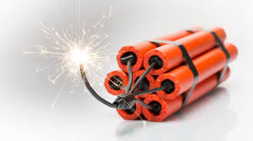

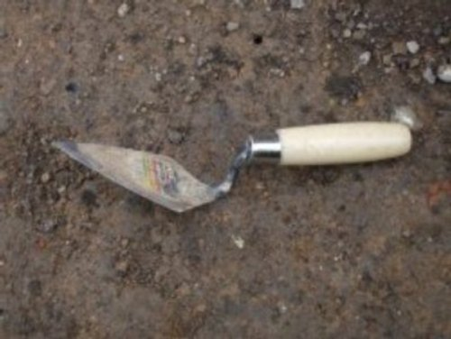

- Identify which tool/tools would archaeologists most likely use on a dig. Outline why they would use this tool and not the others. (5 marks)
Dynamite
Jackhammer
Brush
Trowel
_____________________________________________________________________________

_____________________________________________________________________________

_____________________________________________________________________________

_____________________________________________________________________________

_____________________________________________________________________________

_____________________________________________________________________________

_____________________________________________________________________________

- a) Define relative dating with the use of an example. (3 marks)
_____________________________________________________________________________
_____________________________________________________________________________

_____________________________________________________________________________

_____________________________________________________________________________

b) Define absolute dating with the use of an example. (3 marks)

_____________________________________________________________________________
_____________________________________________________________________________

_____________________________________________________________________________

_____________________________________________________________________________

- Identifying and categorising primary and secondary sources. State the word primary or secondary next to each type of source. Watch your spelling! (6 marks)

NAME OF SOURCE | PRIMARY OR SECONDARY SOURCE
The terracotta warriors, found near the burial site of Shi Huangdi in China
“Unlocking the Past”, a history textbook written in 2008
The original diary of Anne Frank who experienced the holocaust in World War 2
A letter from a World War 1 soldier sent to his family during the Gallipoli campaign.
The written biography on Cleopatra, published in 1978.
Photographs of ancient Roman Ruins

- Read the text below and then answer the lessons that follow:

What Is a Civilization?
A civilisation is generally defined as an advanced human society containing highly developed forms of government, culture, industry, and common social norms.
Historians associate the rise of civilizations with the Neolithic Revolution, in which people learned how to grow crops and rear animals such as sheep and goats, rather than just hunt-and-gather. No longer wandering to gather food and people began settling in locations.
Historians have also identified a geographical region where they believe civilizations first arose. According to historians 'the Cradle of Civilization,' or the Fertile Crescent as it sometimes called, is the region consisting of the present-day countries of Iraq, Iran, Egypt, and a few others. The region between the Tigris and Euphrates rivers is often called Mesopotamia. To the west of Mesopotamia, the Egyptians, the Greeks and the Roman civilisation rose.
- List three factors that define civilisation. (3 marks)
- ___________________________________________________________
- ___________________________________________________________
- ___________________________________________________________
- Refer to the text and list the three countries that are in the region referred to as ‘the Cradle of Civilisation”. (3 marks)
- ___________________________________________________________
- ___________________________________________________________
- ___________________________________________________________

- State the name of the two rivers that flowed through the region called Mesopotamia. (2 marks)
- ___________________________________________________________
- ___________________________________________________________
- State the name of the three well known ancient civilisation that are west of Mesopotamia. (3 marks)
- ___________________________________________________________
- ___________________________________________________________
- ___________________________________________________________

- Explain why the jobs of both a historian and an archaeologist are so important. (5 marks)
_____________________________________________________________________________

_____________________________________________________________________________

_____________________________________________________________________________

_____________________________________________________________________________

_____________________________________________________________________________

_____________________________________________________________________________

_____________________________________________________________________________

_____________________________________________________________________________

_____________________________________________________________________________

_____________________________________________________________________________

_____________________________________________________________________________

_____________________________________________________________________________

_____________________________________________________________________________

_____________________________________________________________________________

_____________________________________________________________________________

- The dates below represent significant events that occurred during Ancient Times. Place the information in the correct sequence to create a timeline about Ancient Civilisations. Remember to use a scale to represent the years and a heading for your timeline. (12 marks)

2500 BC Pyramids built in Egypt | 400 BC Classical age of Greece | 27 BC Roman Empire Begins
356 BC Birth of Alexander the Great | 1500 BC Shang Dynasty of China | 476 AD Roman Empire Falls in the West

